SIHM/AC/ 29th June 2022
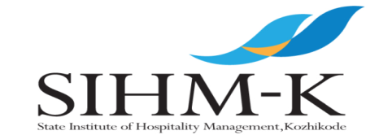
Walk in interview
Applications are invited from qualified candidates for the appointment of visiting faculty in following subjects 1.Food Science & Nutrition 2. Computer Applications 3.Accounts 4.Hotel Engineering
Interested candidates may forward their resume to sihmcalicut@gmail.com and report to the office of the State Institute of Hospitality Management, Varakkal beach, West Hill Kozhikode on 12.7.2022 at 10 am with Curriculum vitae and all credentials in original.
For details visit www.sihmkerala.com
29.6.2022 Principal

WALK - IN INTERVIEW
SCHEDULED FOR 12th July 2022 (Thursday) AT 10AM AT THE INSTITUTE (Nr. Varakkal Beach, West Hill Kozhikode-5)
GUEST LECTURER POSITIONS
1. FOOD SCIENCE & NUTRITION
Post Graduate Degree with food Science or Nutrition related subject from recognized University with 50% marks. At least 2 years of teaching experience in an educational institution
2. Computer Applications Graduate with Computer Science or Computer Application as main or subsidiary subject with 50% marks or MCA. At least 2 years of teaching experience in an educational institution.
3. Accounts M.Com/ICWA with 50% marks. At least 2 years of teaching experience in an educational institution.
4. Hotel Engineering A Graduate in any stream of engineering preferably Civil/Electrical. 3 year practical experience or two year teaching experience.
Interested candidates may appear for an Walk –in Interview at 10am on Thursday, the 12th July 2022 at the Institute with their application for the positions along with originals and one set of attested copies of all relevant certificates and testimonials and a passport size photograph.
For more information please call: 0495-2385861.
Principal i/c

